**Assignment 006 -2**

1. **Distort/ripple**



1. **Distort/spherize**



1. **Filters / Distort / Twirl**

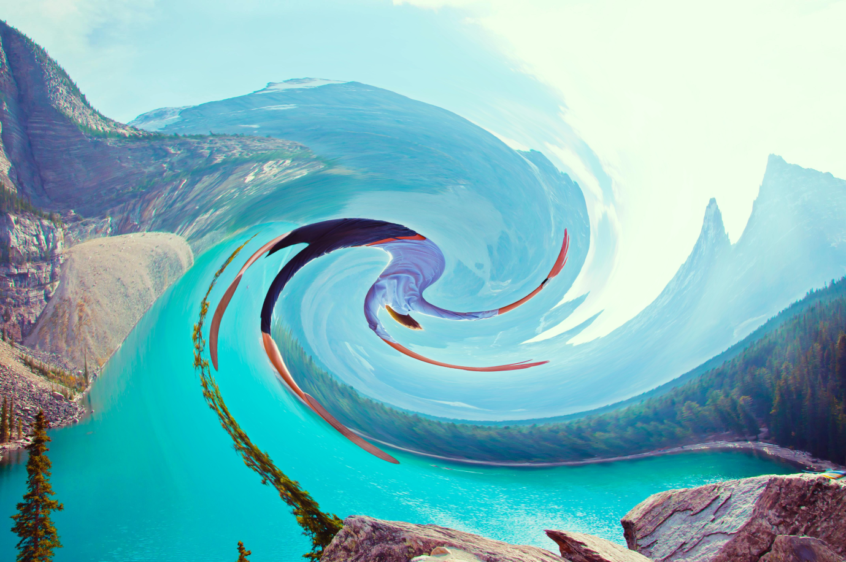

1. **Filters / Distort / Zigzag**



1. **Filters / Aesthetics / Tile**



1. **Filters / Aesthetics / Find edges**

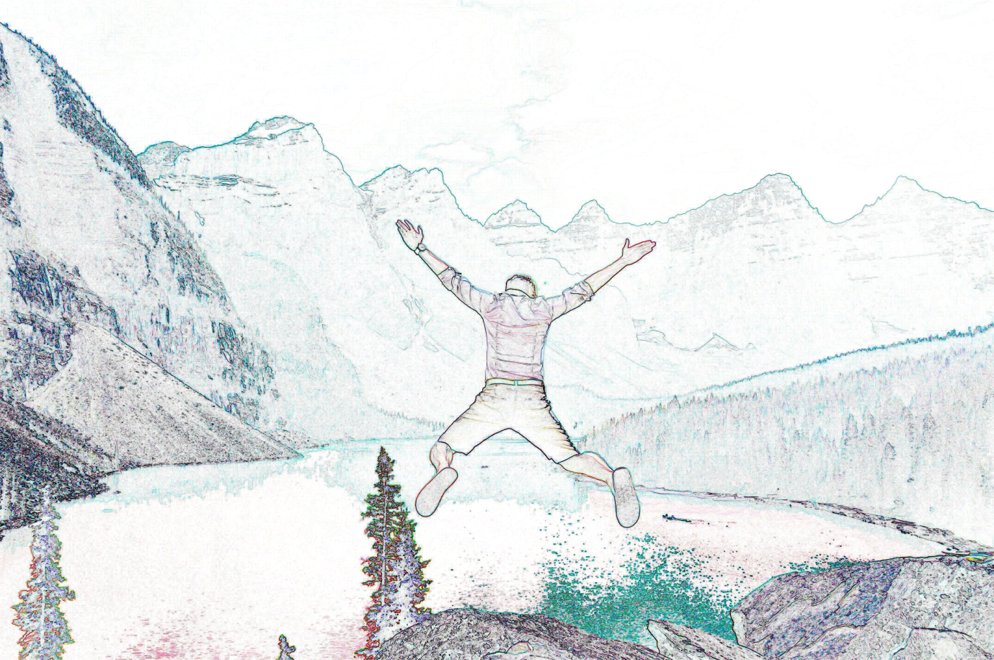

1. **Filters / Aesthetics / Diffuse**



1. **Filters / Aesthetics / Emboss**

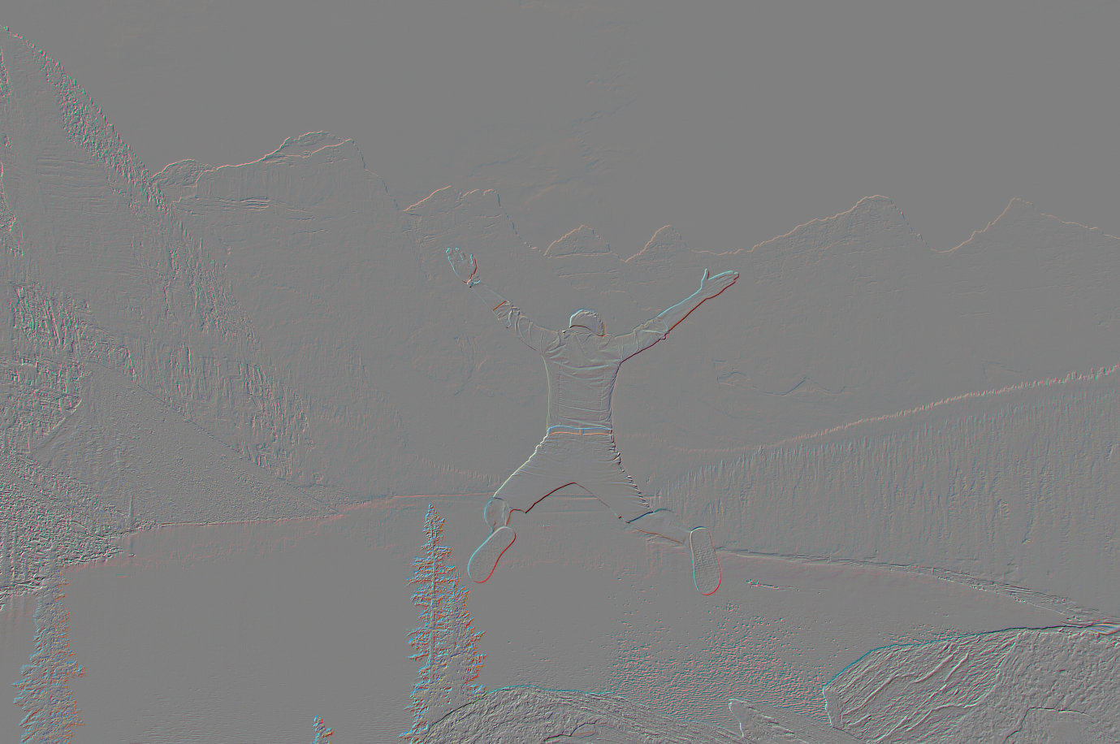

1. **Filters / Aesthetics / Extrude**

